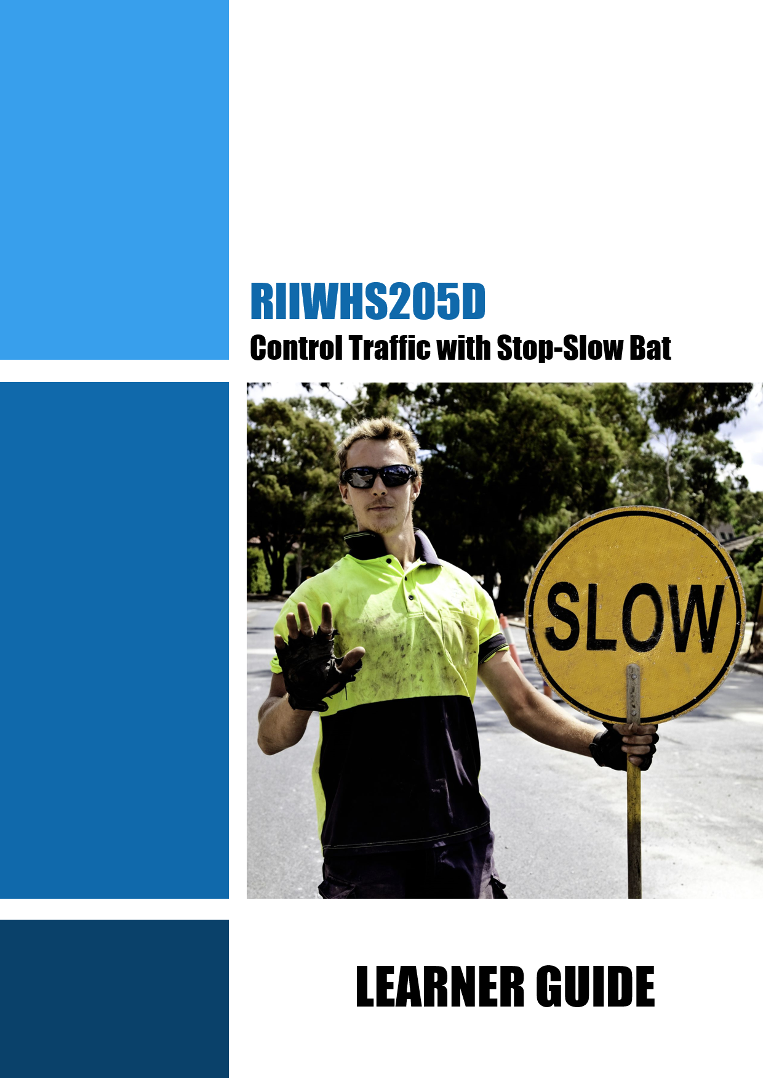

RIIWHS205D Control Traffic with Stop-Slow Bat

Learner Name:
Learner ID:
Learner Contact Number:
Learner Email Address:
Date Training Commenced:

This Book Contains:

- Course Information.
- Review Questions.
- Practical Assessment overview and instructions.
Table of Contents
1.1 Introduction 5
1.1.1 What is Traffic Management? 5
1.2 Traffic Controllers 6
1.2.1 Responsibilities 6
Review Questions 7
1.3 Working Safely 7
1.3.1 Health & Safety Rules 7
1.3.1.1 Regulations and Codes 8
1.3.2 Operations Documentation 9
1.3.3 How to Keep Everyone Safe 9
Review Questions 10
1.4 Work Instructions 11
1.4.1 Reading and Checking Your Work Instructions 12
1.4.2 Work Method Statements 12
1.4.3 Traffic Management Plans 13
1.4.3.1 Traffic Guidance Scheme 13
1.4.4 Emergency Procedures 13
1.4.4.1 Evacuation 14
1.4.4.2 First Aid 14
1.4.5 Environmental Protection Requirements 14
Review Questions 15
2.1 Choose and Check Tools and Equipment 17
2.1.1 Personal Protective Equipment (PPE) 17
Review Questions 18
2.2 Signs and Warning Devices 18
2.2.1 Traffic Controller Signs 19
2.2.1.1 Cones 19
2.2.2 Tools and Equipment 19
2.2.2.1 Stop-Slow Bat 20
2.2.2.2 Types of Radios 20
2.2.2.3 Keep Radios Charged Up 21
2.2.3 Faulty Equipment 21
Review Questions 21
2.3 Prepare the Site 22
2.3.1 Direct Traffic Away from Hazards 23
2.3.2 Site Isolation and Traffic Control 23
2.3.3 Position Signs and Devices 24
Review Questions 24
2.4 Direct and Control Traffic 25
2.4.1 Using a Stop-Slow Bat 26
2.4.2 Use Hand Signals Correctly 26
2.4.3 Working with Other Traffic Controllers 27
2.4.4 Operate Radio 27
2.4.4.1 Adjust Radio Controls 27
2.4.4.2 Radio Use 28
2.4.5 Keep in Contact 28
Review Questions 28
2.5 Controlling Traffic within the Worksite 30
2 .5.1 Monitor Traffic and Conditions 31
2.5.2 Report Traffic Offences 32
Review Questions 33
2.6 Remove Signs and Devices 34
Review Questions 35
2.7 Clean Up After Operations 35
2.7.1 Clearing the Work Area 35
2.7.2 Cleaning, Checking and Maintaining Equipment 36
Review Questions 36
Practical Assessment Instructions 37
Conditions of Assessment 37
Personal Protective Equipment (PPE) Requirements 37
Grounds for Stopping the Assessment 37
Achieving a Satisfactory Outcome 37
Practical Assessments 38

1.1 Introduction


This course is based on the unit RIIWHS205D Control Traffic with Stop-Slow Bat.

You will learn about:

- Planning and preparing for traffic control.

- Controlling and coordinating traffic using signs, radios and a stop-slow bat.

- Cleaning up after operations.

1.1.1 What is Traffic Management?


Traffic movement within or around worksites is particularly hazardous with a high risk of death or injury resulting from personnel coming into contact with vehicles, moving plant, and from collisions between moving plant and other vehicles.

Traffic management is the job of controlling traffic through and around hazardous areas and protecting vehicles, pedestrians and workers. By using signs and signals traffic controllers can safely direct vehicles and pedestrians through the traffic hazard or work area.

All traffic management operations must follow a Traffic Management Plan. The plan normally includes a traffic guidance scheme, worksite hazard assessment and details of the works, (where, what and how long etc.).

A Traffic Management Plan is required by legislation whenever:

- Work affects traffic on public and private roads.

- Work affects parking areas.

- Access to construction sites needs to be restricted from public traffic.

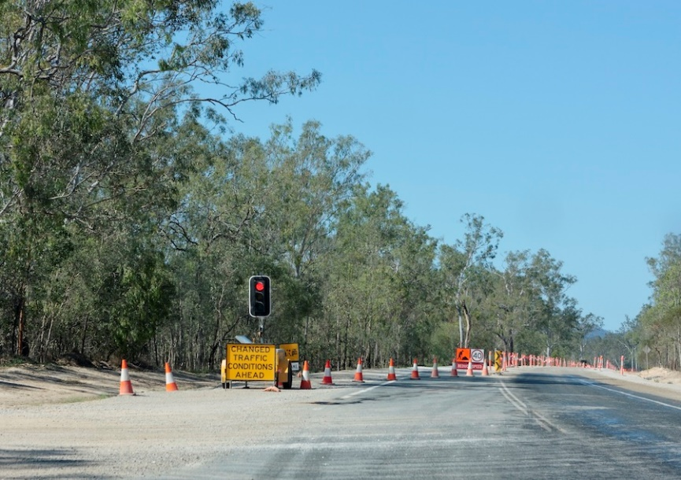

1.2 Traffic Controllers

Traffic controllers are used when signs and devices will not be enough to provide for safety, public convenience and traffic management in and around the worksite.
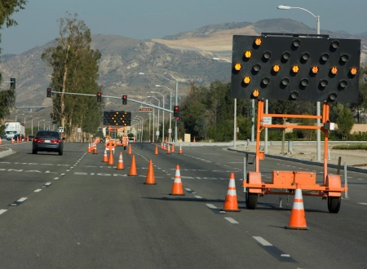
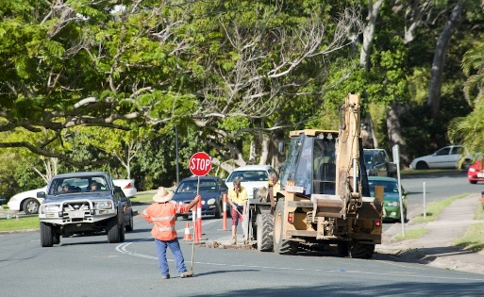
Situations requiring control of traffic by controllers using stop-slow bats are:

- Road surfacing – to slow down, stop or direct traffic as needed.

- Single-lane operation – to restrict traffic to a single direction or control alternating use of the lane.

- Low-speed operation – to warn and slow down traffic.

- Temporary road closures – to stop traffic, to inform drivers of the likely delay and to hold traffic until it is clear or safe to proceed (e.g. blasting works).

- Plant crossings – to stop traffic to allow plant crossing or entering the roadway where needed.

- Limited sight distance in worksite – to warn traffic to slow down due to a potential hazard ahead.

- Emergency situations – to stop and direct traffic as necessary.

1.2.1 Responsibilities


The traffic controller’s main responsibilities are to:

- Provide safe travelling conditions for road users.

- Provide a safe workplace for workers and plant under their control.

- Be familiar with and follow the provisions of legislation and organisational requirements.

- Maintain traffic control in emergencies and other difficult situations.

Review Questions

 | List 3 examples of situations where traffic controllers use stop-slow bats. | 
1.

2.

3.

1.3 Working Safely

You must follow all safety rules and instructions when performing any work. If you are not sure about what you should do, ask your boss or supervisor. They will tell you what you need to do and how to do it in a safe way.

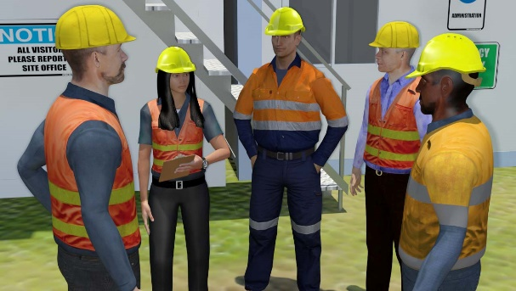

1.3.1 Health & Safety Rules

Every workplace has to follow laws and rules to keep everyone safe. There are 4 main types:

Acts | These are laws that you have to follow.
Regulations | These explain what the law means.
Codes of Practice | These are instructions on how to follow the law, based on industry standards.
Australian Standards | These tell you what the minimum requirement is for a job, product or hazard.

Some states use OHS laws, and other states use WHS laws. They both talk about the same thing, but use different words or names for people. If you have any questions about safety rules you should talk to your boss or supervisor.
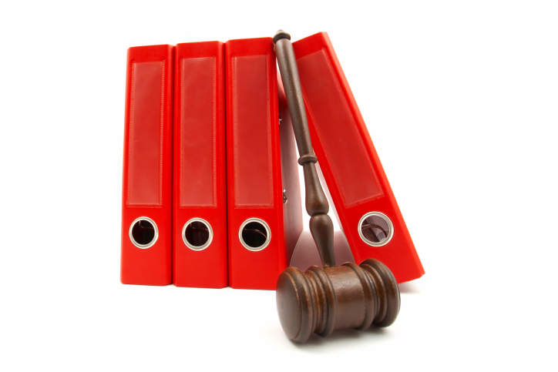
The most important health and safety rules for traffic controllers are:

- State and territory traffic management legislation.

- Regulations and codes of practice.

- Australian Standard AS1742.3 - 2009: Manual of Uniform Traffic Control Devices (MUTCD) - Part 3: Traffic Control Devices for Works on Roads.

Each state and territory has Regulations and a Code of Practice for traffic management at roadworks based on and incorporating AS1742.3.

These documents outline the roles and responsibilities of traffic controllers.

1.3.1.1 Regulations and Codes

To find out what regulations and codes of practice apply in your state or territory visit the appropriate road and traffic authority office website.

State/Territory | Department | Website
ACT | Dept. of Territory and Municipal Services | www.tams.act.gov.au
NT | Dept. of Lands and Planning | www.dpi.nt.gov.au
NSW | Roads and Traffic Authority | www.rta.nsw.gov.au
QLD | Dept. of Transport & Main Roads | www.mainroads.qld.gov.au
SA | Dept. for Transport, Energy & Infrastructure | www.transport.sa.gov.au
TAS | Dept. of Infrastructure, Energy & Resources | www.transport.tas.gov.au
VIC | VicRoads | www.vicroads.vic.gov.au
WA | Main Roads | www.mainroads.wa.gov.au

In Australia, traffic management regulations require that anyone who is required to work in traffic control must have appropriate traffic control training.

1.3.2 Operations Documentation

Before starting your work you need to make sure you have access to all operations documentation for the job. This will help you to do your work in the safest way and make sure all work is compliant.

Operations documentation includes:

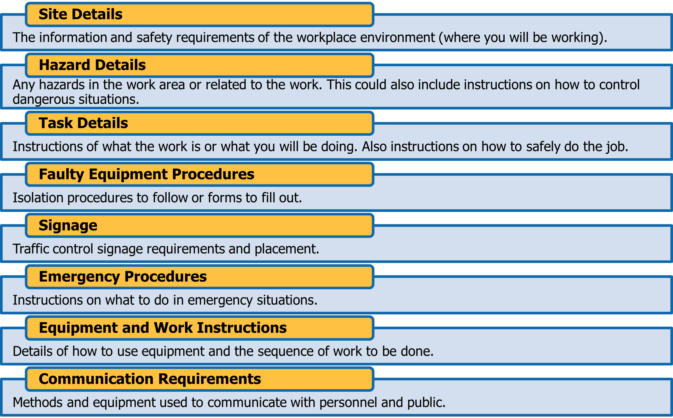

1.3.3 How to Keep Everyone Safe

WHS law says that all companies and personnel need to keep themselves and other people safe while they work. This is called a duty of care.

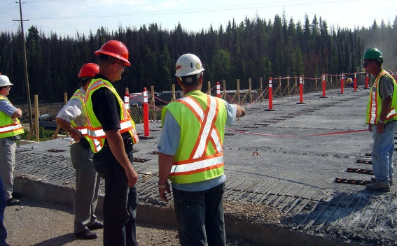
To keep yourself and other personnel safe you need to:

- Follow your instructions.

- Follow all workplace rules.

- Make sure all equipment is safe to use.

- Carry out your work safely.

- Report any problems.
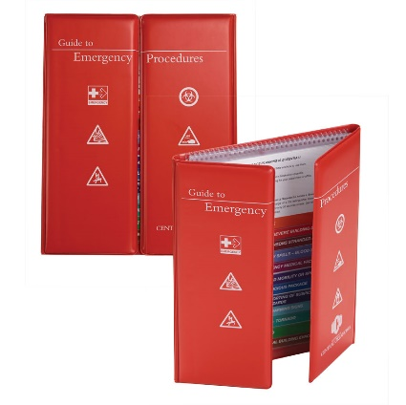
If you think something is dangerous tell your boss or supervisor as soon as possible.

Your worksite will also have instructions for working safely including:

- Emergency procedures, including first aid and evacuation.

- Safe work practices.

- Personal protective clothing and equipment.

- Safe use of tools and equipment.

Review Questions

What are the 4 main types of laws and rules that you need to follow?
1.

2.

3.

4.

List 3 things that may be included in ‘operations documentation’.
1.

2.

3.

What can you do to make sure you meet your Duty of Care requirements to keep yourself and other workers safe?

1.4 Work Instructions

You need to be clear about what work you will be doing. Make sure you have everything about the job written down before you start. This includes what you will be doing, how you will be doing it and what equipment you will be using.

Make sure you have all of the details about where you will be working, such as information about the site, weather, hazards and traffic conditions.

You will need to be clear about your role in regards to:

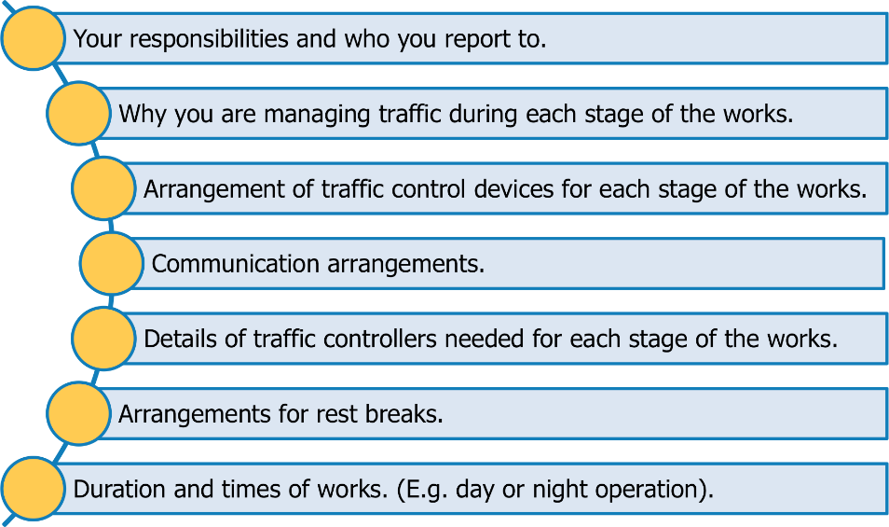
You also need to make sure you have all of the details about the kind of work you will be doing. Work instructions for a traffic controller will outline these details and should include guidelines for:

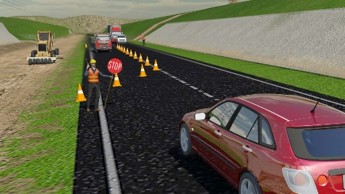
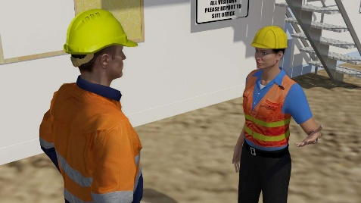
- Wearing approved high visibility clothing.

- Use and placement of warning signs.

- Safe approach speeds up to 60 km/h.

- Safe distances from approaching traffic and work area.

- Communication practices.

- Best positioning for visibility and line of sight.

- Having a clear escape path.

- Taking frequent rest breaks to avoid fatigue.

- Training requirements of anybody performing traffic management.

1.4.1 Reading and Checking Your Work Instructions


All work needs to follow worksite, environment and company safety procedures.

Procedures help to make sure that all work is done in a safe way, without damaging equipment or putting people in unsafe situations. They also help to make sure that work is done in the correct order and doesn’t interrupt or get in the way of other work that is happening on the site. This is especially important in projects that need to be completed in a particular sequence.

Your work instructions will tell you the safest way to do the job, and the equipment that you will need to use. It is a good idea to check your work instructions with your boss or supervisor to make sure you know exactly what you need to do.

If you don’t know where to get your instructions or you can’t understand the language or terminology being used in them, you can ask your boss or supervisor. They will tell you where to find your work instructions and explain what they mean.

1.4.2 Work Method Statements

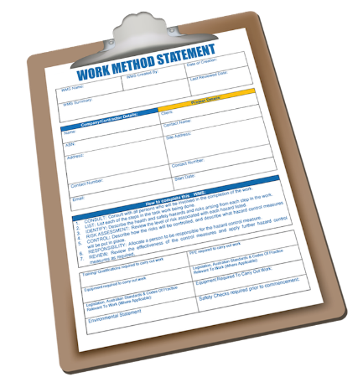
Many worksites require a work method statement before any work can start. A work method statement is a list of steps that outlines how a job will be done. It also includes any hazards that occur at each step, and what you need to do about them.

These statements can also be known as Safe Work Method Statement (SWMS), Job Safety Analysis (JSA) or Safe Operating Procedure (SOP).

Work Method Statements are used for organising your work activities and making sure you have completed everything. They will also outline the details of all tools, equipment and coordination with other personnel relating to your job. Make sure all of these are available and ready before you start.

1.4.3 Traffic Management Plans

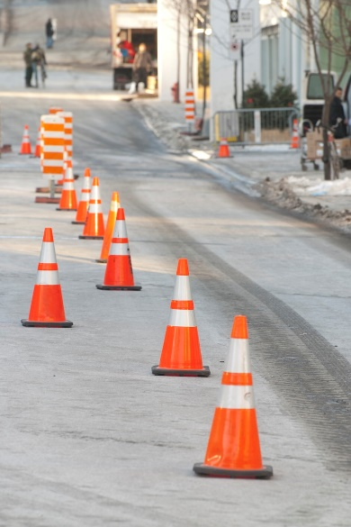
The Traffic Management Plan aims to:

- Protect personnel, road users and pedestrians.

- Guide road users safely through, around or past the worksite.

- Provide proper warnings of changes in the road surface, driving conditions and of people or machinery engaged in work.

- Reduce the impact of the works on traffic and others likely to be affected.

- Reduce disruptions to public transport.

- Communicate details of works and possible impacts on traffic.

1.4.3.1 Traffic Guidance Scheme

The plan must include a Traffic Guidance Scheme. This shows, on a diagram or sketch, the physical location of traffic control signs and devices being used to guide traffic around a work area or temporary hazard.
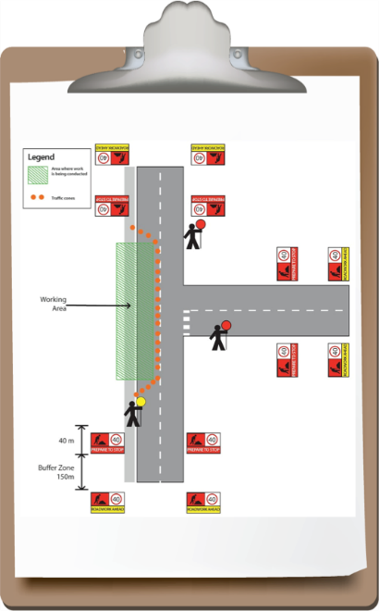
This may include:

- Warning signs.

- Lights.

- Markers.

- Cones.

- Bollards.

- Barriers.

- Road and footpath closures.

- Detours or side tracks.

- Traffic controllers.

1.4.4 Emergency Procedures


Emergency procedures will vary depending upon the worksite. These procedures could include:

- Evacuation.

- First aid.

1.4.4.1 Evacuation

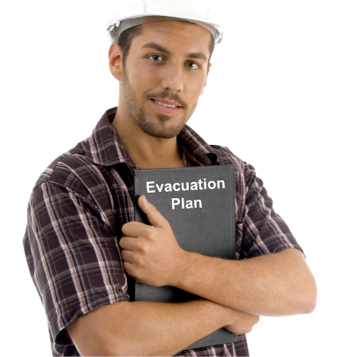
Things to remember are:

- Keep calm.

- Move away from the danger to a designated evacuation point, sometimes
called an emergency assembly area.

- Do not let other people into the area.

- Call emergency services in accordance with workplace procedures and
policies.

1.4.4.2 First Aid

First Aid is the quick care given to an injured or ill person. Every site will have a First Aid Officer.

If somebody needs first aid you must tell your supervisor or First Aid Officer. Do not try to give first aid if you have not been trained.

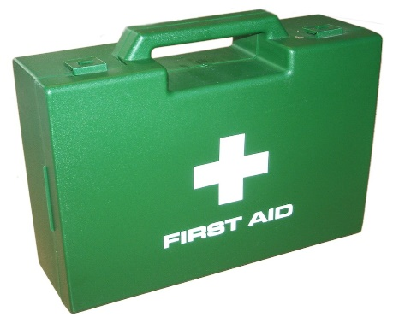

1.4.5 Environmental Protection Requirements

Environmental protection requirements are part of every worksite. Make sure you check with your supervisor about what environmental issues need to be managed during your work.


All environmental details should be listed in an ‘Environmental Management Plan’ for the site. It can include details for:

- Waste management.

- Water quality protection.

- Noise control.

- Vibration control.

- Dust management.

The plan will outline the steps and processes needed to prevent or minimise damage to the environment through the use of machinery and equipment.

Review Questions

List 3 guidelines that should be included in your work instructions.
1.

2.

3.

What will your work instructions tell you?

What is a Work Method Statement?

List 3 aims of a traffic management plan.
1.

2.

3.

What emergency situations are generally outlined in site emergency procedures?

What does an environmental plan outline?

2.1 Choose and Check Tools and Equipment

Once you have confirmed your job requirements you need to choose the right equipment to get the job done.

Information about technical capabilities and limits can be found in the operator manuals for each item.


When choosing equipment you need to think about:

- The task requirements, specifications and goals.

- The appropriateness of the equipment for the completion of the task.

- The characteristics, correct use, operating capacity and limitations of each item.

- The potential risks to yourself and others in the intended use of the equipment.

2.1.1 Personal Protective Equipment (PPE)

Personal Protective Equipment (PPE) is clothing and equipment designed to lower the chance of you being hurt on the job. It is required to enter most work sites.

Because of the potential hazards associated with working on or next to road worksites, all personnel and visitors to such worksites, will be supplied by their employer with the relevant protective equipment. High visibility equipment and clothing must be worn on site at all times.

This equipment and clothing should meet the relevant standard and comprise the following items:

- High visibility clothing:
- Fluorescent high visibility vest, shirt, jacket or overalls (day use only).
- Retro-reflective outer garment (night use only).

- Safety footwear.


Also as required:

- Safety helmets (hat or cap type) that comply with the current Australian Standard.

- High visibility cloth hats where safety policy permits.

- Approved skin protection (sunscreens).

- Wet weather clothing (high visibility).

High visibility clothing must meet the requirements of AS/NZS 1906.4-1997: Retro-reflective Materials and Devices for Road Traffic Control Purposes, Part 4: High Visibility Materials for Safety Garments.

Make sure any PPE you are wearing is in good condition, fits well and is right for the job. If you find any PPE that is not in good condition, tag it and remove it from service. Tell your supervisor about the problem and they will organise to repair or replace the PPE.

Review Questions

List 3 things that you should think about when selecting equipment and attachments.
1.

2.

3.

2.2 Signs and Warning Devices

The Traffic Management Plan should state the types, sizes and numbers of signs and devices required for the project.
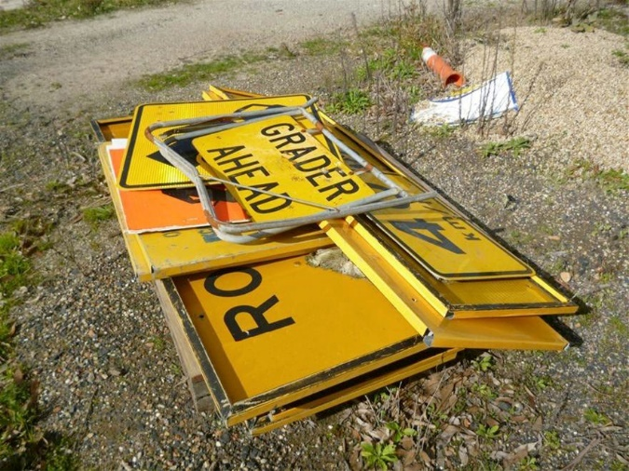
Signage and warning devices required at all sites are:

- Temporary warning signs.

- Regulatory and traffic cones.

Temporary warning signs are used to alert the public of changed conditions ahead, for example:

- Roadwork ahead.

- Prepare to stop.

- Workers (symbolic).

AS 1742.3-2009 is the accepted reference for the selection and use of any traffic control signs and devices on worksites.
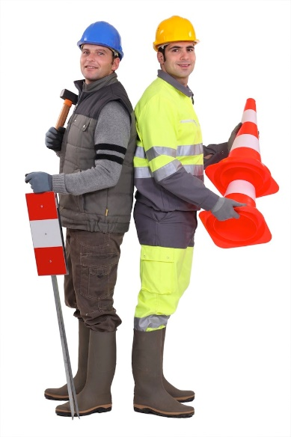
Other signs and devices that may be used depending on the work include:

- Warning signs.

- Vehicle mounted signs and flashing lights.

- Guide signs.

- Barriers.

- Hazard markers.

- Bollards.

- Arrow boards.

2.2.1 Traffic Controller Signs

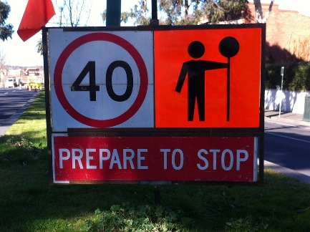
Whenever a traffic controller is on duty, the “Traffic Controller Ahead – PREPARE TO STOP” sign must be displayed.

A traffic controller is responsible for making sure the “Traffic Controller Ahead – PREPARE TO STOP” sign is set up correctly when the shift begins or resumes and also making sure the sign is removed or covered when work ceases or is suspended during a shift.

2.2.1.1 Cones

Traffic cones are generally used on short-term works to define the traffic path past or around the work area.

Various sizes are available for different situations such as footpaths or freeways.

2.2.2 Tools and Equipment

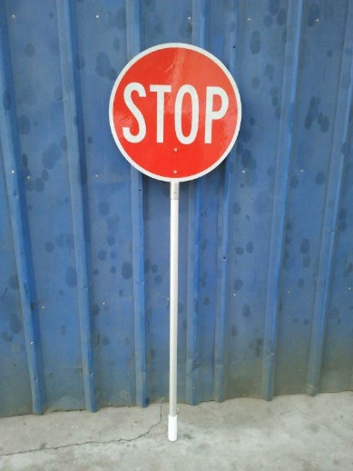
In addition to the traffic signs and devices, other tools and equipment may be needed to carry out tasks or requirements of the job.

Tools and equipment may include:

- Stop-slow bat.

- Illuminated wand.

- Radio.
A temporary hazard marker, a temporary barrier or a boom barrier may be used to assist the traffic controller.

If a boom barrier is used, the STOP sign may be mounted on the boom. Other equipment may include warning lights and beacons and arrow boards.

Characteristics, technical capabilities, uses and limitations of regulatory equipment used can be found in AS 1742.3-2009 and the relevant state or territory Code of Practice.

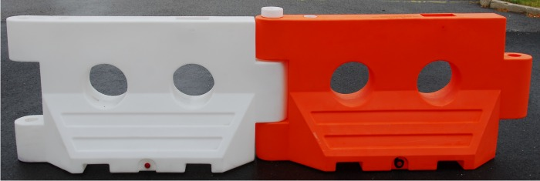

2.2.2.1 Stop-Slow Bat
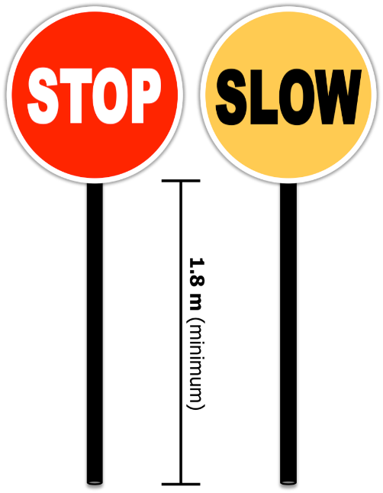
An essential item of equipment for a traffic controller is the stop-slow bat.

This is a double-sided hand held sign with STOP on one side and SLOW on the other. The handle should be a minimum of 1.8m long.

Traffic control bats should be made of retro-reflective material, clean and in good repair.

Damaged or defaced bats should be repaired or replaced promptly. For night operations, an illuminated wand should be used as well as the bat.

2.2.2.2 Types of Radios

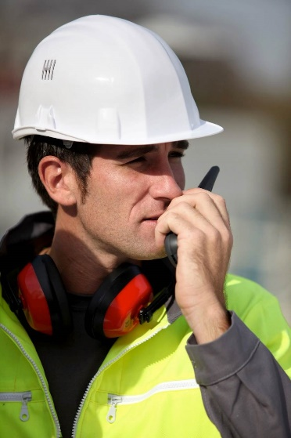
You may use VHF or UHF radios on site. Make sure you are on the right channel to speak with other workers. If work is being done on a large site you may need to use fixed channel radios to stop interference or messages going to the wrong people.

Fixed channel radios will also help to prevent other vehicle’s radios (e.g. trucks) from interfering with site communications.

2.2.2.3 Keep Radios Charged Up
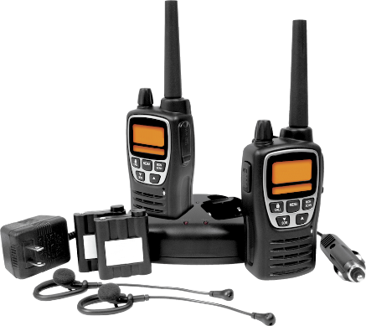
Radios work on batteries. For the radio to work you must keep them charged.

If the work is going to be done over a long period of time, the condition of the battery should be closely monitored. You should also have spares available just in case the batteries run out during operations.

Always check the amount of charge in the battery before the start of every shift. At the end of work check how much charge is left and recharge if required.

2.2.3 Faulty Equipment


Any defective equipment needs to be dealt with in accordance with site procedures. At minimum it should be reported to the supervisor for replacement or repair.

You will need to report any problems, faults, defects and damage that you have found so that they can be repaired and the equipment is safe for you or the next operator to use.

Make sure the equipment is tagged out (isolated from use) until the repairs have been made.

Record the details of the problem in a fault report as required by your site procedures.

Review Questions

What 2 types of signage and warning devices are required at all sites?
1.

2.

What sign must be displayed when a traffic controller is on duty?

How long should the handle be on a stop-slow bat?

What should you check on a radio at the start of every day?

2.3 Prepare the Site

Once you have gathered and checked your tools and equipment and read the requirements and instructions for the job you will be ready to direct traffic.

Directing traffic uses a combination of signage and traffic controllers.

Make sure you follow the traffic management plan and coordinate traffic control activities with other personnel on site.

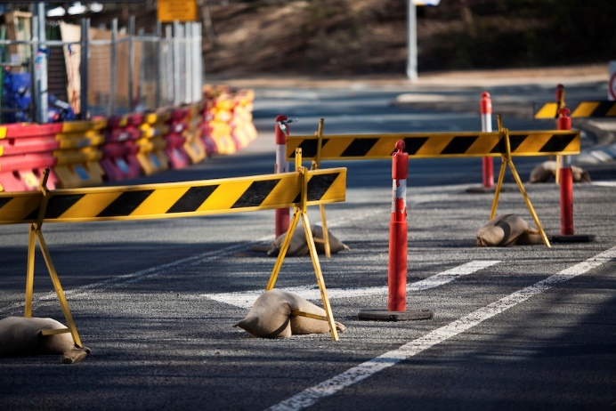

2.3.1 Direct Traffic Away from Hazards

While preparing the site you should check for any hazards that are in the work area. Examples of hazards you may find on your worksite include:

Hazard Category | Examples of Hazards | Hazard Category | Examples of Hazards
Worksite Hazards | - Excavations  - Recently filled trenches.  - Pits.  - Poles.  - Trip hazards.  - Hazardous materials. | Traffic Hazards | - Traffic control.  - Other machines.  - Working in proximity to others.  - Worksite visitors and the public.  - Personnel.  - Vehicle traffic.
Structural Hazards | - Bridges.  - Surrounding buildings.  - Obstructions.  - Structures.  - Facilities.  - Underground services.  - Overhead services. | Environmental Hazards | - Trees.  - Uneven/unstable terrain.  - Embankments.  - Cuttings.  - Dirt mounds.  - Low light or night conditions.  - Sun and heat.  - Inclement weather.  - Fires.  - Fatigue.

Make sure you keep all traffic away from hazards or dangerous situations as much as possible.

2.3.2 Site Isolation and Traffic Control
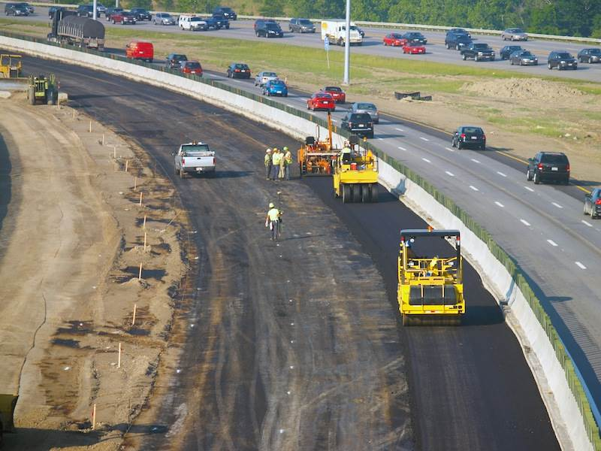
Isolating the worksite using fences or barriers is the best way to provide better safety for personnel and the general public.

However where this is not possible, appropriate traffic control methods will help protect personnel from traffic.

Passage of traffic through a work area should only be permitted where both the traffic and the work can be adequately controlled.

Traffic controllers or traffic signals should be used as needed to slow traffic on the approach to an active work area, to stop traffic when required for the movement of plant or other operations, or to control single lane flow.

Some traffic control devices need authorisation from the Road Traffic Authority, including works speed limit signs for speeds less that 40 km/h, and traffic signals.


Traffic paths past the work area must be clearly set out. Where the route changes from normal, this may require the obliteration of original pre-works markings that are likely to confuse drivers and personnel.

When it is too dangerous to allow traffic through the work area, either a detour using existing roads or a special side-track can be used.

Prior approval of the signing layout should be obtained from the State Department or local government as appropriate.

2.3.3 Position Signs and Devices

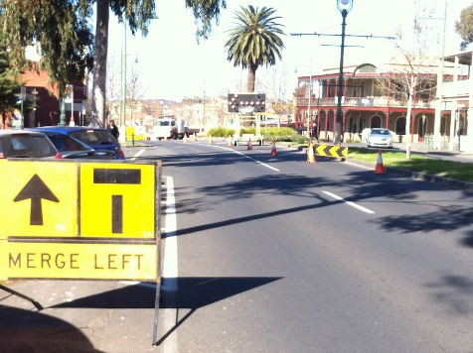
Worksite signage must be placed in accordance with the Traffic Management Plan.

Signs should face towards approaching traffic approximately at right angles to the line of sight from the driver to the sign.

Generally signs and devices are placed on the left hand side of the road, at a distance that does not present a hazard to passing traffic.

On multi-lane roads and where traffic is dense, the signs should be placed on both sides of the roadway.

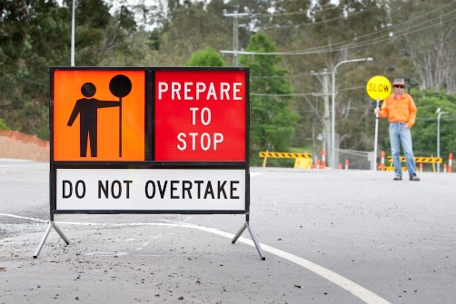
The advance warning “Traffic Controller” symbolic sign and the “Prepare to Stop” sign must be in place facing approaching traffic at all times while traffic control is in operation.

It is the responsibility of the traffic controller to ensure the signs are in place while controlling traffic and are removed or covered when operations are suspended temporarily or finished for the day. Relieving controllers should also check that the signs are installed correctly.

The position of the signs will vary depending on the traffic approach speed.

The maximum approach speed of traffic in advance of a Traffic controller is 60 km/h. Temporary speed limit signs should be displayed as necessary.

You may also need to set up signs to safely direct or detour pedestrian traffic around the side of, or away from work sites. Make sure barricades or fences are used as well to make sure you prevent any pedestrian traffic from accidentally entering a work area.

Review Questions

List 3 traffic hazards that can be found on a worksite.
1.

2.

3.

How should signs be placed on multi-lane roads where traffic is dense?

2.4 Direct and Control Traffic

A traffic controller controls traffic in a professional manner to enable drivers to negotiate through or around the worksite safely in accordance with the site traffic plan.

The traffic controller is employed to direct traffic away from services or areas of potential damage or danger, and to ensure the safety of personnel.

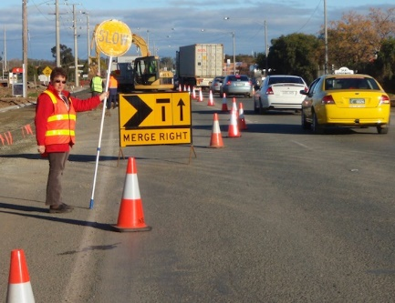
The accepted procedures for controlling traffic are:

- Stand at least 30m in advance of the work area and so approaching traffic can see you from at least 1½ times the approach speed. (For example, at 60 km/h the line of sight distance should be 90m.)

- Stand on the kerb or shoulder, clear of the traffic and in clear view of oncoming traffic.

- Wait for a suitable gap in the traffic before attempting to stop vehicles.

Once all traffic has stopped, you may step onto the roadway and walk to a position in front of the first vehicle giving the STOP hand gesture.

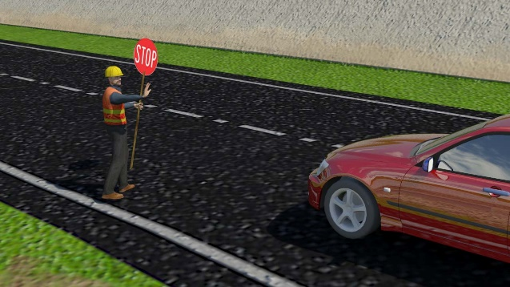
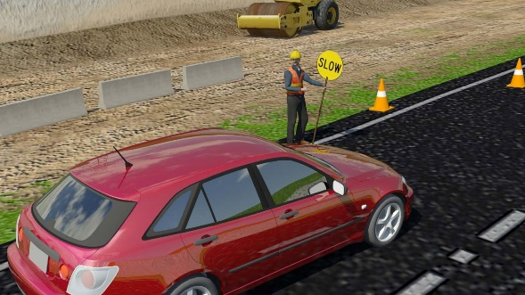
- Extend the bat high over the roadway at an angle of 45 degrees with the STOP banner facing the traffic.

- If a large vehicle is obscuring your visibility to approaching traffic, project the STOP bat out past the vehicle for other drivers to see.

- Always stay at the head of the traffic queue and do not allow other people to gather near you.

- When it is clear to move the traffic on, first check the road ahead is clear and then move to the side of the road.

- Turn the bat to display the SLOW sign and give the GO gesture with the free hand.

- To slow traffic, stand on the kerb or shoulder with the SLOW banner displayed, and make the SLOW gesture with the free hand.

- When using the stop-slow bat, hold it upright and extend the arm out from the body.

- Never turn your back to traffic and always have an escape route.

2.4.1 Using a Stop-Slow Bat

Traffic controllers must use hand held stop-slow bats in accordance with regulatory authority approved procedures. The bat should be kept clean, and damaged or defaced bats should be replaced.

The traffic controller should never:

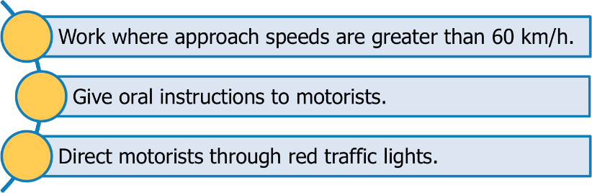

2.4.2 Use Hand Signals Correctly

Traffic controllers can only use hand signals to direct traffic in conjunction with a stop-slow bat.

There are 3 standard signals to use:

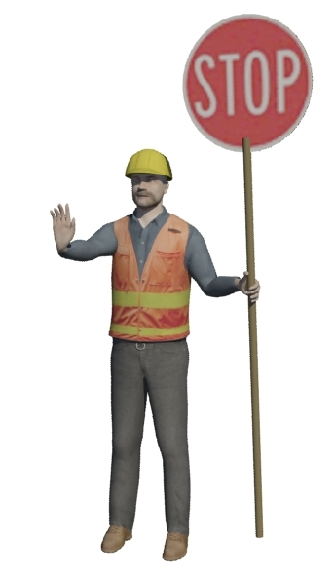 | 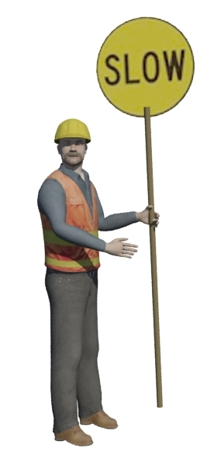 | 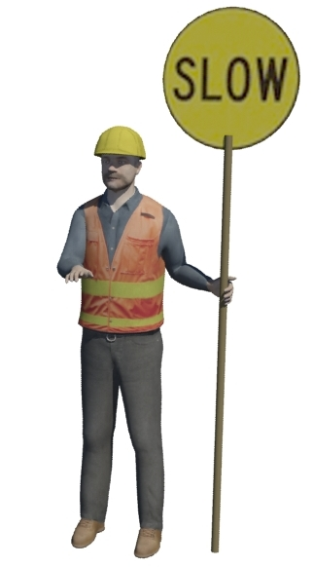
STOP | GO | SLOW
Stand face-on with STOP displayed and raise the free hand with the palm facing the traffic to signal STOP. | Stand side-on with SLOW displayed and motion the free arm across in front of the body, to signal GO. | Stand face-on with SLOW displayed and move free arm in a vertical arc, palm down, to signal GO SLOW.

At night time an illuminated wand can be used when making the hand signals.

Under state laws, traffic controllers have no authority to control or direct traffic by hand signals alone or by giving oral instructions to drivers.

2.4.3 Working with Other Traffic Controllers

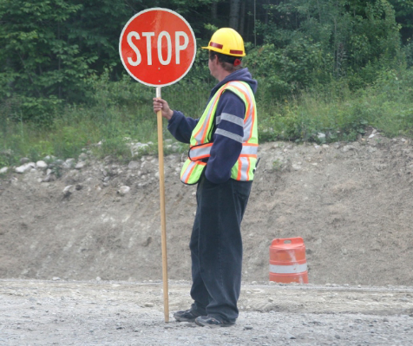
Where two traffic controllers are operating, the controller displaying the SLOW banner has control of the site.

Once the final vehicle has passed or there is a gap in traffic, this controller turns the bat from SLOW to STOP.

The other controller waits until the traffic path is clear and the other bat is displaying STOP before turning his or her own bat from STOP to SLOW and allowing traffic to proceed in the other direction.

If there is no line of sight between the traffic controllers, either radio contact or an intermediate communicator should be used.

2.4.4 Operate Radio


Traffic controllers may need to use radios to talk over longer distances, or when they cannot clearly see each other.

You need to be familiar with site communication protocols for using the radio, and the frequencies or channels to be used.

If you aren’t familiar with radio operations or that particular model, get somebody to show you how it works.

A shoulder strap attachment may be required to allow hands-free operation when controlling traffic.

Note: Radios must not be used in the vicinity of blasting operations. Signals can interfere with the operations.

2.4.4.1 Adjust Radio Controls

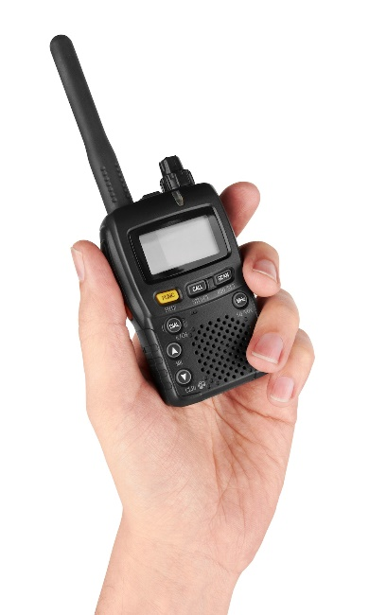
To use a radio properly, you need to know how to adjust the volume to a level that lets you hear messages over any worksite noise.

You may need to adjust the power setting and select the appropriate channel.

Power is often the Volume control.

There may also be controls for Mode, Squelch or frequency setting – get explanations for these from your supervisor.

You can usually select channels on your radio by pushing up or down buttons.

Each channel has a specific assignment, so before you begin talking make sure that you’re allowed to use that channel.

Press the push-to-talk (PTT) button and send a test transmission in accordance with site procedures. Adjust the power setting or channel as required.

2.4.4.2 Radio Use

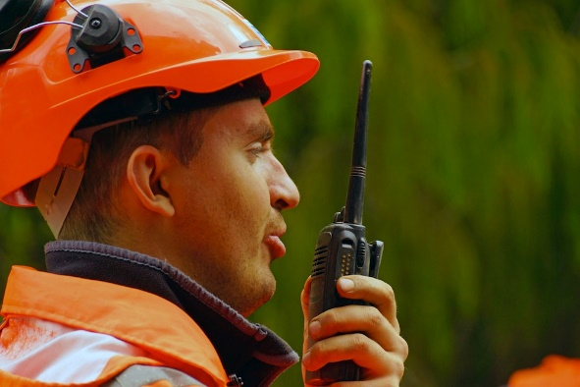
The radios typically use a push-to-talk button and you release the button to listen. Hold the microphone approximately one inch from your mouth. Make sure your messages are clear and simple.

When using a two way radio remember:

- Use a call sign when trying to contact somebody.

- Sign off each time you have finished speaking. (Terms generally used are ‘over’ or ‘out’ but not ‘over and out’.)

- Speak clearly and concisely.

2.4.5 Keep in Contact

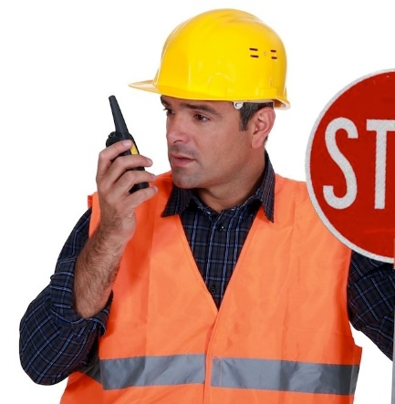
At large worksites or where visual contact is restricted, you may need to report regularly to your supervisor, maintain contact with other traffic controllers, or receive updates on work progress or anticipated delays.

Always check in at the appointed times. If you should have received a scheduled contact and have not by the nominated period, you should call the person to check the reason for non-contact.

Review Questions

What should be done with damaged or defaced bats?

What 3 standard hand signals are to be used to direct traffic?
1.

2.

3.

Who has control of the site when two traffic controllers are operating?

What button should you push to send a test transmission?

What terms are generally used to sign off after you have finished speaking on a radio?

What should you do if you have not received your scheduled contact by the nominated period?

2.5 Controlling Traffic within the Worksite

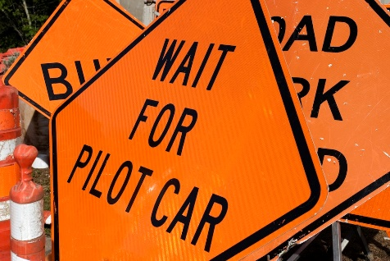
Passage of traffic through a work area should only be permitted where both the traffic and the work can be adequately controlled.

A guide vehicle may be needed to lead traffic along the desired path and to control its speed.

Controllers may be used for controlling the movement of plant within the work area. These vehicles require longer time and distances to stop and are more difficult to manoeuvre.

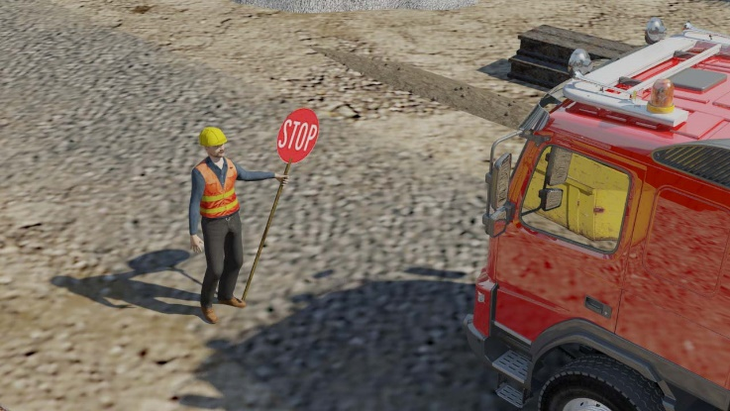
Traffic controllers may be used to control trucks delivering or removing equipment or materials at crossing points and at site entry/exit points.

Traffic controllers may also need to direct pedestrian traffic away from hazardous work areas or other dangers while work is being done. You may have to direct pedestrians or traffic towards site delivery, parking or other safe areas to avoid incidents and keep the whole site as safe as possible.

Make sure you use clear instructions and signals when directing any traffic around the work site. This will help to make sure people know exactly where to go, and that they travel at a safe speed.

2 .5.1 Monitor Traffic and Conditions


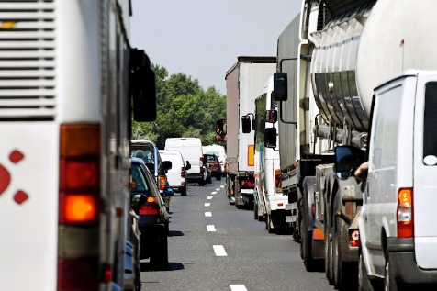
The traffic controller should be alert to any changing traffic conditions that may affect how you perform your job.

Traffic conditions may include:

- Congested urban environments.

- Low traffic rural areas.

- Off-road un-trafficked areas.

- Buildings.

- Parking sites.

- Pedestrian areas.

Where traffic volume means that traffic queues will form, make sure that waiting vehicles do not obstruct intersections, railway crossings or access to residences and shopping areas.

If road conditions change, due to progress of the work or prevailing weather conditions, or work continues into the night, make sure that traffic will still be able to stop in time.
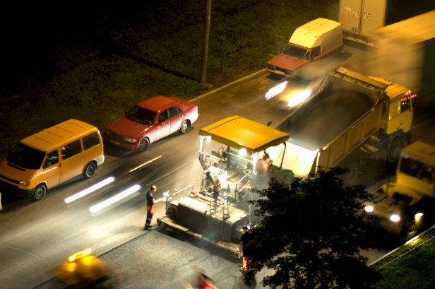
At 60 km/h the stopping distance for an average car is 90m given reasonable road conditions.

Remember that heavy vehicles require longer time and distances to start and stop.

If the roads become wet or surface changes make conditions dangerous, the distance of the warning signs and/or the speed limit may need changing.

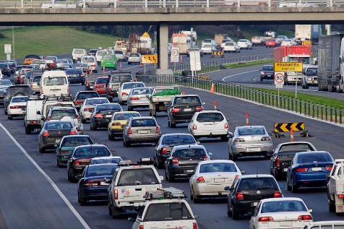
A traffic controller’s normal duty is to remain at the head of the traffic queue while traffic is stopped.

If there is a possibility of vehicles colliding with the end of the queue, or of drivers queue jumping because they cannot see the traffic controller, an additional traffic controller and/or additional warning signs should be placed at the tail end of the queue.
The visibility of a traffic controller to motorists can be affected during a shift by:
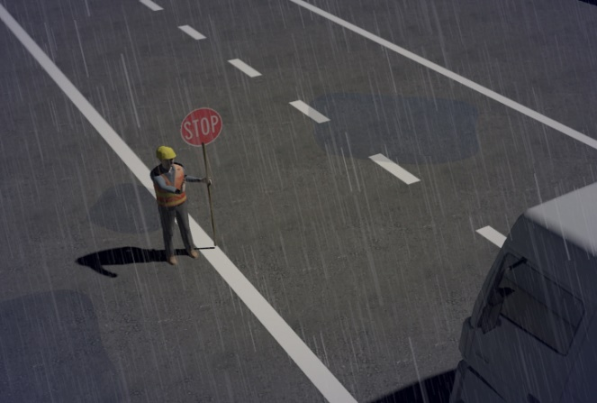
- Fog.

- Dust.

- Heavy rain.

- Changes in the position of the sun.

- Background conditions.

- Shaded areas.

- Oncoming headlights.

Consider these factors when deciding where to position yourself and take extra care.

Where factors outside your control lead to lengthy delays, it may be necessary to arrange for additional warning signs and/or traffic controllers.

2.5.2 Report Traffic Offences

The traffic controller has no legal powers. The legal authority rests with the STOP sign, which means that motorists must stop when it is displayed.

The driver must stop as near as practicable to the sign and not proceed beyond it while it is displayed.

The law does not apply to the SLOW sign, which is advisory in nature and used for guidance only.

The traffic controller should report to the supervisor motorists who fail to follow reasonable directions. The supervisor will pass on the details to the police or relevant authority.

If an offence occurs, such as a vehicle failing to stop at traffic controls, do not attempt to stop the vehicle.

Immediately attempt to warn the personnel ahead using your radio or communications equipment and write down the details of the vehicle and the offence.
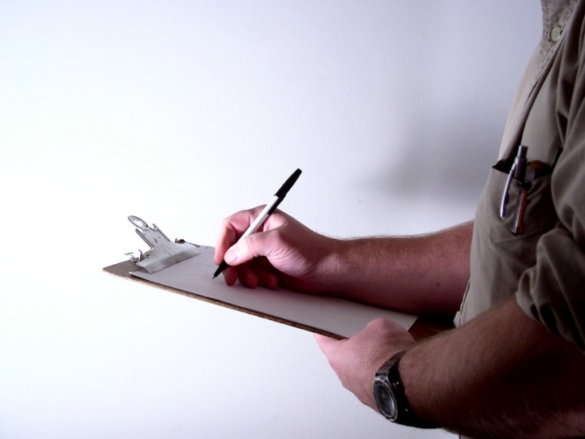
If possible note the:

- Registration.

- Vehicle make.

- Body type.

- Colour.

- The time, date and location of the offence.

Review Questions

Why may a guide vehicle be needed?

List 3 things that can affect the visibility of motorists.
1.

2.

3.

What types of vehicles require longer time and distances to start and stop?

What 5 details should be noted in the event of a traffic offence?
1.

2.

3.

4.

5.

2.6 Remove Signs and Devices

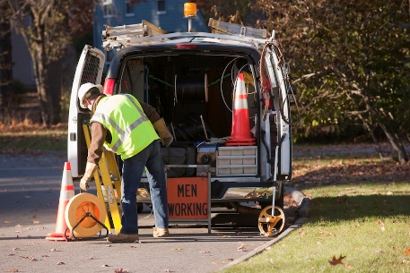
It is important that signs and devices are removed or concealed from view (hidden) as soon as any activity is completed or a hazard no longer exists.

Make sure the “Traffic Controller” symbolic sign and the “Prepare to Stop” sign are removed or covered when the traffic controller is not on duty.

Traffic control signs and devices are removed in reverse order, starting from the work area out to the approaches. This is to continue to give maximum warning during removal of sign and devices.

Remove signs and devices in the following order:

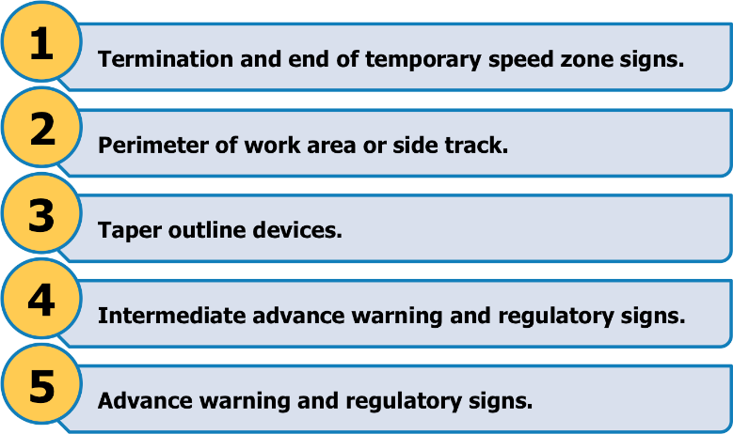

A vehicle displaying a vehicle-mounted warning device should be used between the personnel and the traffic to protect personnel retrieving the taper devices.

Review Questions

What 2 signs should be removed or covered when the traffic controller is not on duty?
1.

2.

2.7 Clean Up After Operations

Once all your tasks are finished, you will need to clean up the site. This includes removing any tools and equipment that have been used.

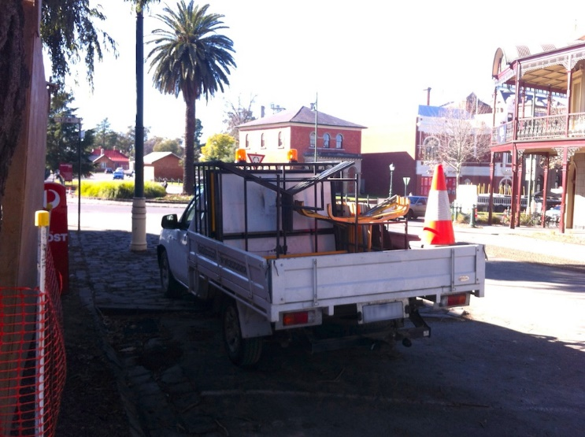

2.7.1 Clearing the Work Area

In clearing your work area you will be carrying out housekeeping activities.


Housekeeping procedures on your site may include:

- Eliminating or controlling any potential hazards. Your duty of care means you shouldn’t leave a possible source of danger or accident for others.

- Removing any hazard controls that are no longer needed, e.g. temporary fences, barricades and signage.

- Packing up, maintaining and storing equipment and tools.

Good housekeeping will help you to see any problems or hazards on the worksite. This will help you to make sure the working environment is safe.

It is your responsibility to clean up after your work activities and not leave it to someone else to do.

2.7.2 Cleaning, Checking and Maintaining Equipment

All tools and equipment must be kept in good working order. This means cleaning, checking, maintaining and storing them correctly, by following worksite procedures and manufacturers’ guidelines.
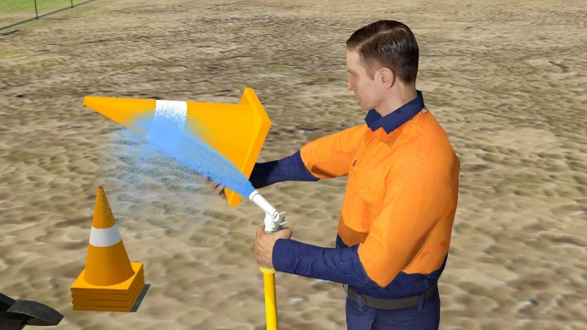
Clean all items by removing dirt, mud, moisture or other contaminants.

While you are cleaning, check each item for damage or wear and tear. If anything is wrong report it, repair it, or have it fixed by a qualified person.

Tools and equipment need to be maintained in line with manufacturers’ recommendations or your worksite procedures. It is important to maintain tools and equipment to prolong their working life and so they operate safely and effectively.

Ensure the items are stored correctly to protect them from the weather and prevent theft.

Review Questions

What should you do while you are cleaning equipment?

